Plugging into future:

An exploration of electricity consumption patterns

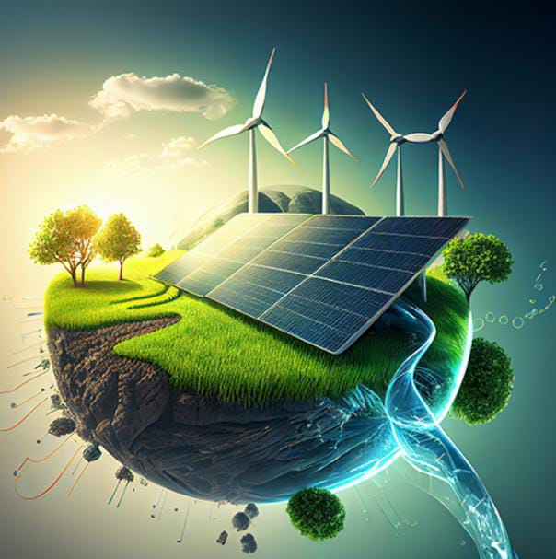

**PROJECT REPORT Plugging into future: An Exploration of Electricity Consumption**

1.INTRODUCTION

1.1 Overview

The Objective of our project is to analyse and identify the reason for over usage of Electricity Consumption during summer from the month of March to June. This project will take a look at various alternate source for Electricity Consumption. This analyzation is done using Tableau. Our supreme aim is to reduce Electricity Consumption and enhance the usage of Renewable Energy. The result of this analysis will be helpful in improving alternate patterns of Electricity Consumption.

1.2 Purpose

The purpose of this project is to examine and visualize the cause for higher electricity usage in order to make well use of available energy.

Electricity is a powerful thing. In order to use its benefits, it is necessary that the amount of electricity in the grid corresponds with actual consumption needs. Due to the ever-increasing demand and growth in popularity of such advances as electric vehicles, there are several challenges power grid operators need to face...

In fact due to several advance techniques, such as renewable energy and solar cell applications, the researchers are bring to bring the zero-energy loss system in the electricity usage and Tamilnadu electricity board electricity consumption data with respect to years also represented the similar results and it is presented in Fig.1. Tamil Nadu data was reported at 94,592.000 GWh in 2021. This records a decrease from the previous number of 95,919.000 GWh for 2020.

And still there are five major challenges to be taken in the account to reduce the energy losses and they are as follows:

[1] Growing amount of renewable energy sources

[2] Electricity transmission losses

[3] Frequent power outages

[4] Electro mobility

[5] Grid modernization



Tamilnadu electricity board electricity consumption data with respect to years

2. Problem Definition & Design Thinking

2.1 Empathy Map

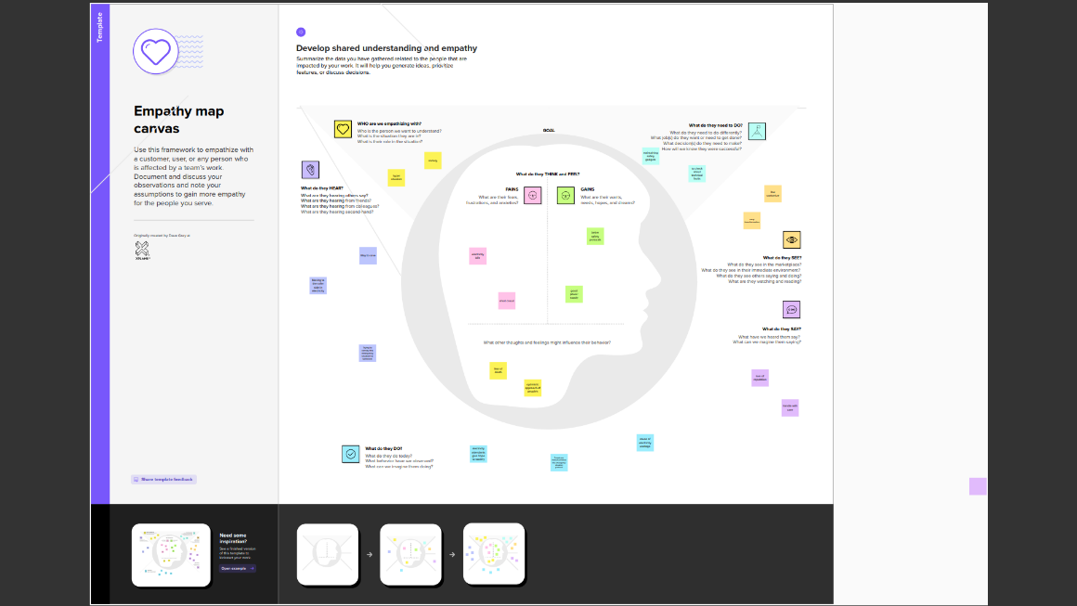

<https://drive.google.com/file/d/1NxOwGv8Iee1Vkp2qI7B6w6eBjSk83-nw/view?usp=share_link>

2.2 Ideation & Brainstorming Map

<https://drive.google.com/file/d/1drAlsyxq-xbKm_SX4-cpj3Y5j9hEdlFG/view?usp=share_link>

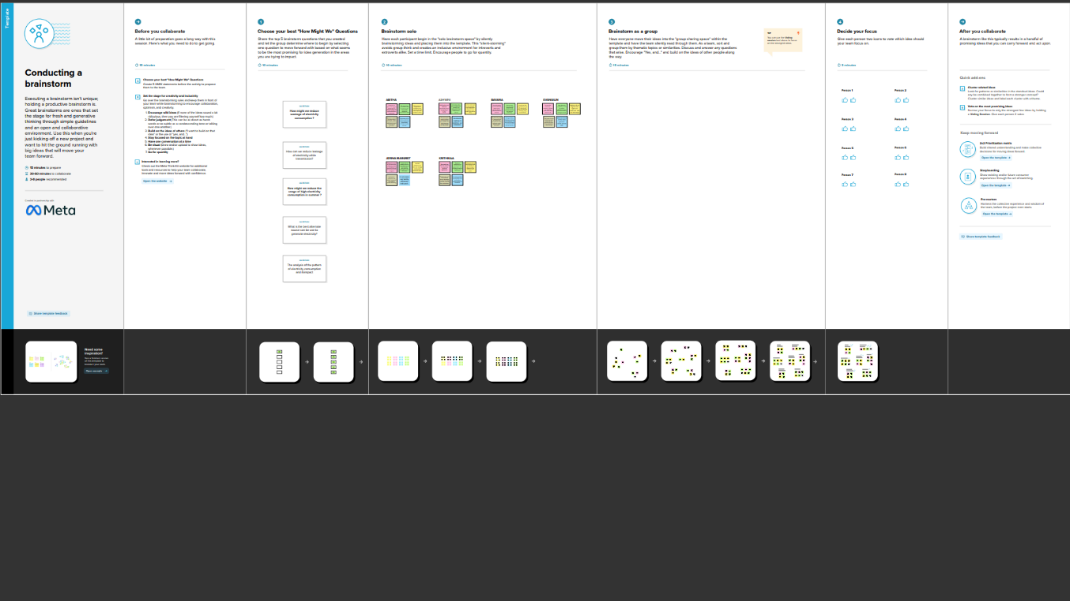

3. RESULT:

The following results can be enfold from our project:

1. The maximum usage of Electricity was in the time of summer i.e, from the month of March to June.
2. The cause for this high consumption rate of Electricity is due to extreme heat during the summer.

This result was acquired after examining the dataset.

Hence the solutions will be:

People can’t reduce or sacrifice their requirements in the usage of electricity but they can change the electricity consumption pattern. Like we can use Renewable energies to generate electricity.

Some of the alternate source to generate electricity are

1. Implantation of Solar Plates
2. Implantation of small Windmill

3. i) SOLAR PLATES

A solar cell panel, solar electric panel, or solar panel, also known as a photo-voltaic module or PV panel, is an assembly of photovoltaic solar cells mounted in a frame. Solar panels capture sunlight as a source of radiant energy, which is converted into electric energy in the form of direct current electricity.

Since more sunlight can be received during summer we can generate more electricity through the solar panels.

For a home we need 10 – 15 solar panels this is enough to generate between 3-5 kilowatts of power which is enough to meet the energy need of a typical household.

The price of 1 solar panel will be around 30,000 INR to 60,000 INR

3. i) SMALL WINDMILL

A wind turbine turns wind energy into electricity using the aerodynamic force from the rotor blades, which work like an airplane wing or helicopter rotor blade.

The function of a residential wind turbine is the same as that of a larger scale wind turbine; it's just smaller and only serves one property. A wind power generator for home use turns naturally occurring wind power into electricity, using the aerodynamic force from the rotor blades.

A 1.5-kilowatt wind turbine will meet the needs of a home requiring 300 kilowatt-hours per month in a location with a 14 mile-per-hour (6.26 meters-per-second) annual average wind speed

Price Range of small windmill - RS 45000 - 1300000.

These alternate sources if implemented for the domestic purposes the consumption of electricity which is generated from the renewable energy can be reduced. The advantages and applications have been discussed in the next section.

The data visualization steps are attached below

DASHBOARD

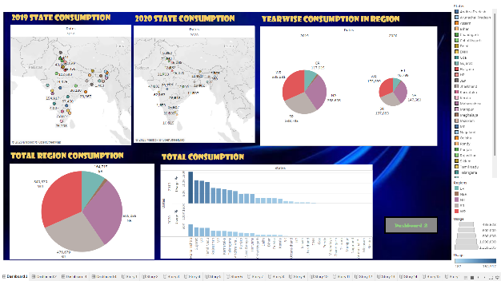

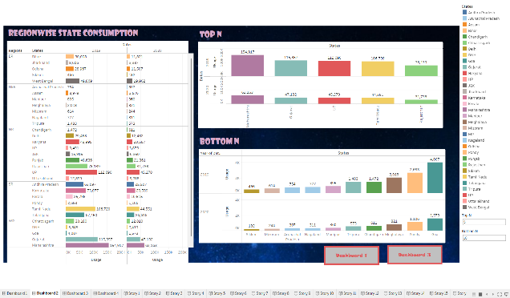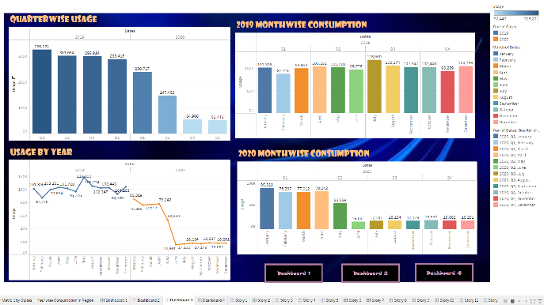

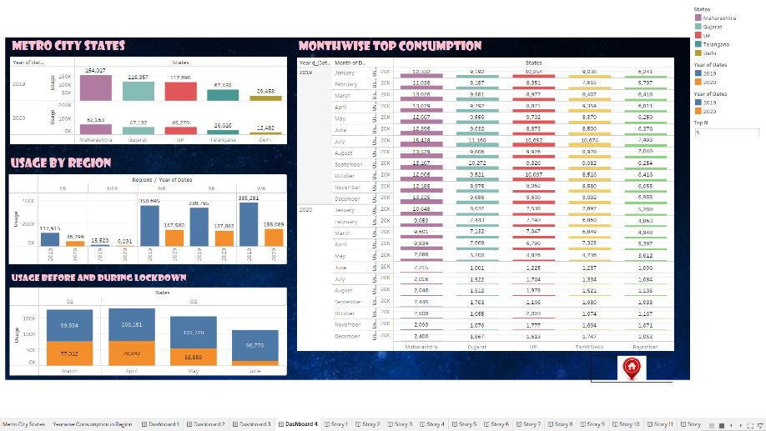

STORY

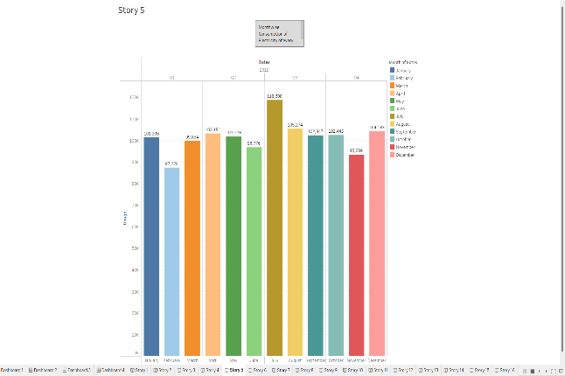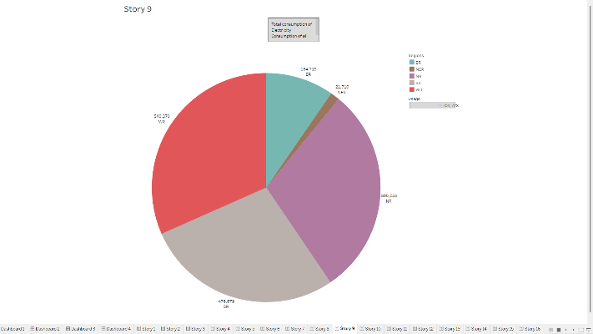

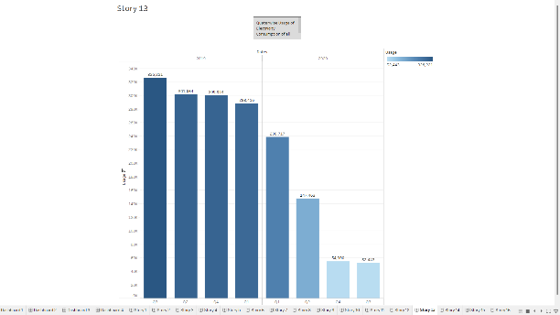 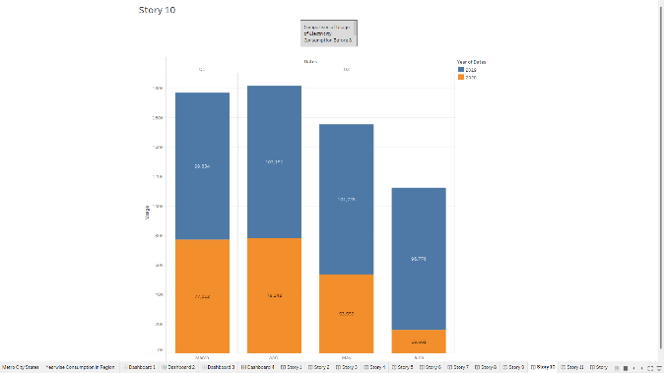B

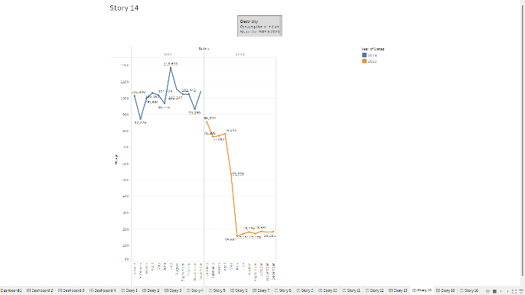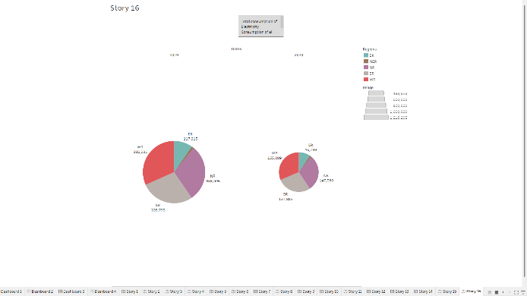

4. ADVANTAGES & DISADVANTAGES

Some of the advantages and disadvantages in the implementation of solar panels and windmills are given below

Advantages:

1. It is uses Renewable source of energy hence it is available infinitely and with free of cost.
2. Its initial cost may be high but maintenance cost will be low compared to electricity bill. Hence there will be no need for paying electricity bill every month.
3. Some 10-15 solar panel or a small windmill is enough to generate the required electricity to run a house.
4. It is also eco-friendly not harmful for nature & living beings.
5. It will not cause pollution.

Limitations:

1. It depends on seasons and climate as sunlight will not be found all the time to charge solar panels.
2. It depends on regions i.e., all the regions will not have same wind flow and sunlight where Kashmir is the coolest place while Rajasthan is the hottest place.
3. Its initial cost for implementation will be so high that normal people cannot afford.

5. Application

The most commonly used solar technologies for homes and businesses are solar photo voltaic for electricity, passive solar design for space heating and cooling, and solar water heating. Businesses and industry use solar technologies to diversify their energy sources, improve efficiency, and save money. Solar Water Heating, Solar Heating of Buildings, Solar-distillation, Solar-pumping, Solar Drying of Agricultural and Animal Products, Solar Furnaces, Solar Cooking, Solar Electric Power Generation.

Wind- mills in pre-industrial areas were used for many things, including irrigation or drainage pumping, grain-grinding, saw-milling of timber, and the processing of other commodities such as spices, cocoa, paints and dyes, and tobacco. If your area is windy enough, home wind turbines can help lower electricity bills by as much as 50-90% and provide an uninterrupted power source through extended utility outages—all with zero emissions and pollution.

6. Conclusion

The following conclusion can be extracted from our project:

* The high consumption of Electricity was observed in summer season.
* The major cause for this high Electricity consumption is due to high temperature in summer.
* Due to this extreme heat people use Electricity to run electrical appliances like A/C, Fan, Air cooler, Refrigerator etc.,

To overcome this alternate pattern of electricity consumption is implemented i.e., implementation of solar cells and small windmill for domestic purposes. This will reduce our electricity bill. It is infinite source & eco-friendly.

7. Future Scope:

There is great future scope for the renewable source in the field of Electricity generation.

**Solar Energy:** In the coming years, technology improvements will ensure that solar becomes even cheaper. It could well be that by 2030, solar will have become the most important source of energy for electricity production in a large part of the world. This will also have a positive impact on the environment and climate change.

With a target of achieving 175 GW of renewable energy capacity by 2022, including 100 GW from solar energy, India is well on its way to becoming a major player in the global solar energy market.

The increasing efficiency of solar panels: Solar panels are becoming more efficient at converting sunlight into electricity. This means that the same size panel is able to generate more electricity, which can reduce the overall cost of a solar energy system.

**Wind Energy:** The Wind Vision Report shows that wind can be a viable source of renewable electricity in all 50 states by 2050. Wind energy supports a strong domestic supply chain. Wind has the potential to support over 600,000 jobs in manufacturing, installation, maintenance, and supporting services by 2050.

By 2025-26 the share of wind power is targeted at 33.01 per cent. Considering this trend, India is expected to install nearly 19.4 Gw of wind capacity, 76 per cent of which will come from central tenders, followed by state utility markets, and lastly commercial and industrial segments.